**JOBSHEET 5 WEB LANJUT**

**BLADE VIEW, WEB TEMPLATING(ADMINLTE), DATATABLES**



**GWIDO PUTRA WIJAYA**

**TI-2A**

**10**

**2341720103**

**D-IV TEKNIK INFORMATIKA**

**JURUSAN TEKNOLOGI INFORMASI**

**POLITEKNIK NEGERI MALANG**

**Praktikum 1: Integrasi Laravel dengan AdminLTE3**

* composer require jeroennoten/laravel-adminlte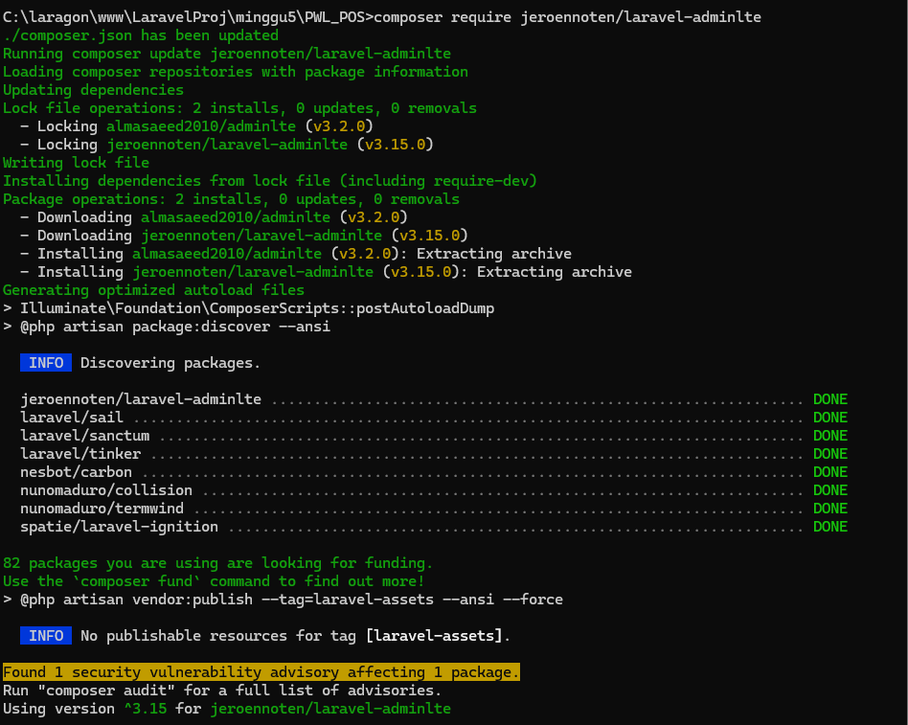
* Melakukan instalasi requirement project di atas dengan command berikut:

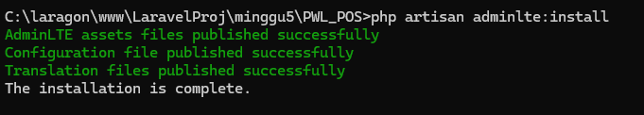

Tampilan dashboard AdminLTE

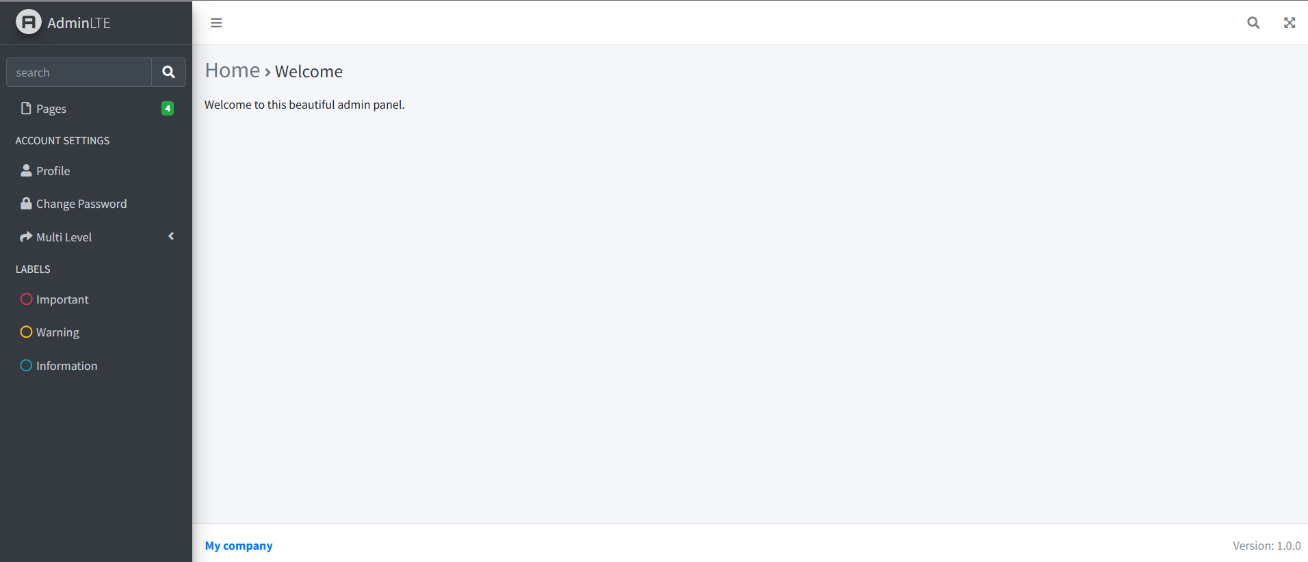

**Praktikum 2 Integrasi dengan DataTables**

* composer require laravel/ui –dev

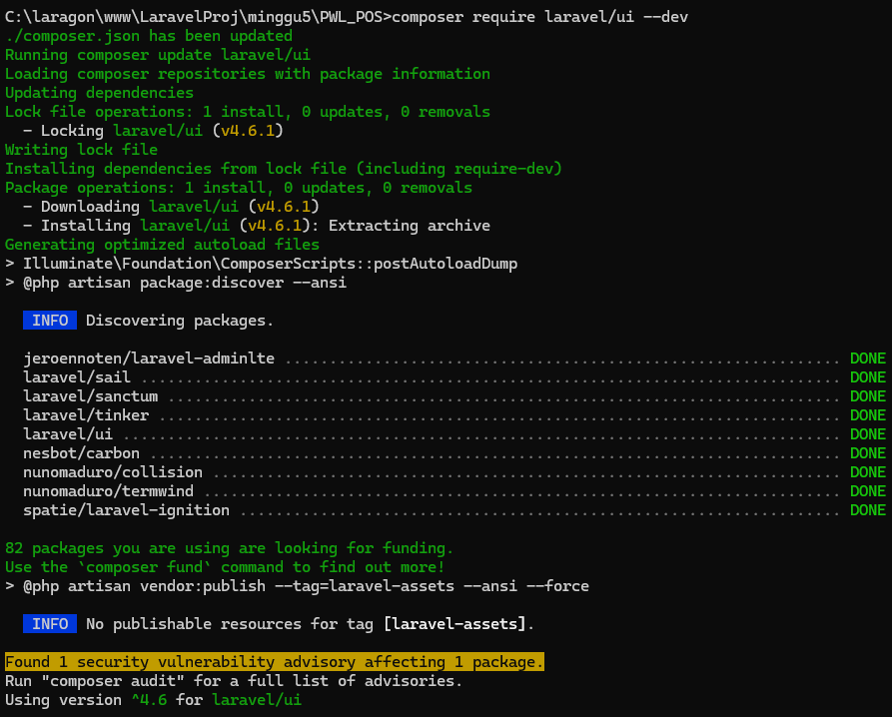

* composer require yajra/Laravel-datatables:^10.0

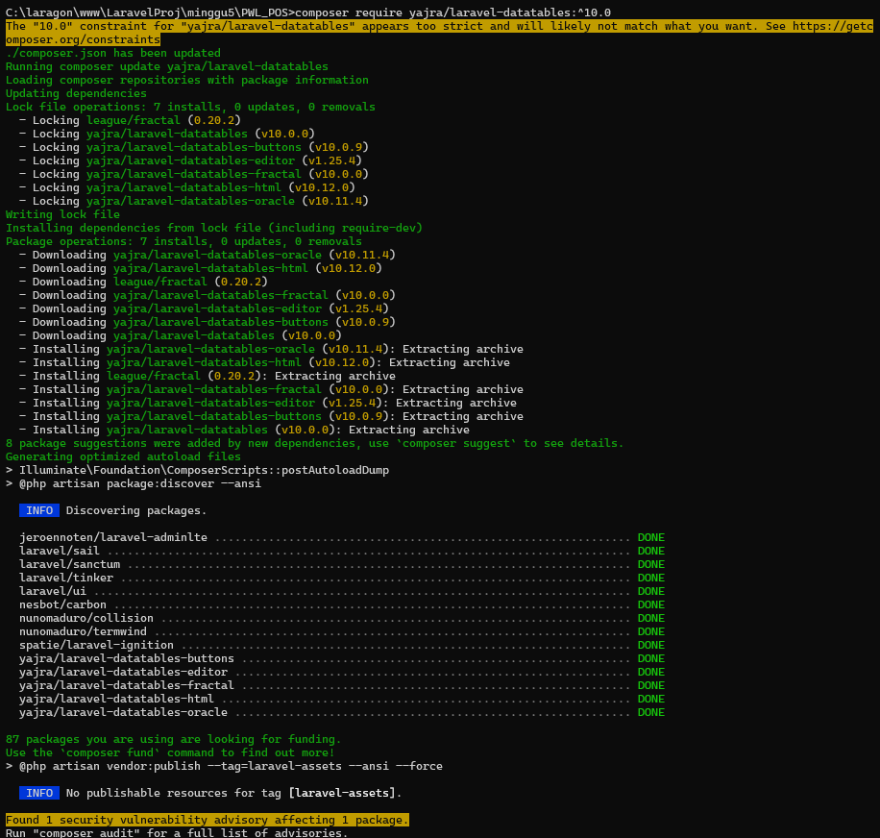

* npm -v

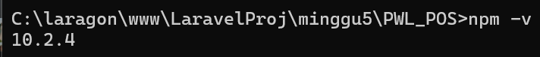

* npm -i laravel-datatables-vite --save-dev

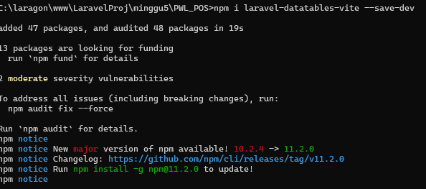

* npm install -D sass

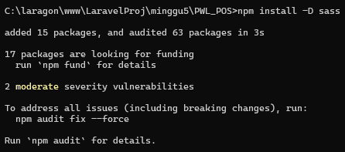

* npm run dev

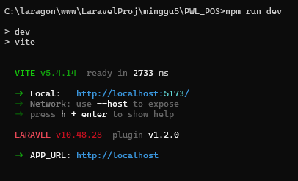

* php artisan datatables:make kategori

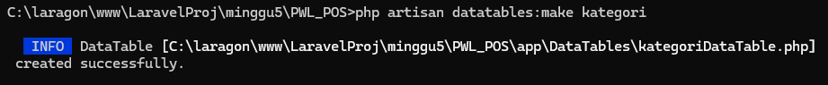

* Tampilan dashboard kategori

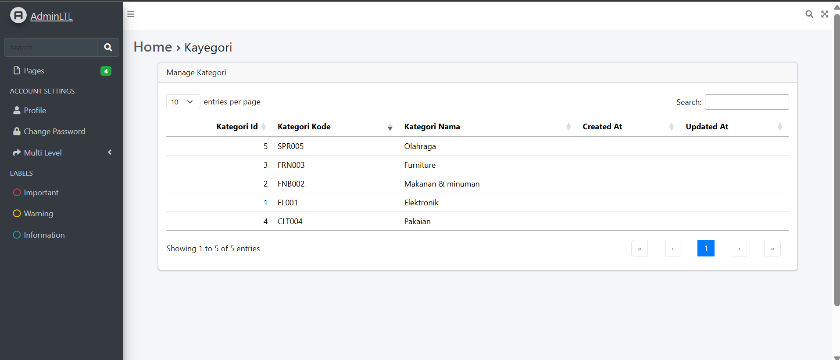

**Praktikum 3 - Membuat form kemudian menyimpan data dalam database**

* Tampilan kategori/create

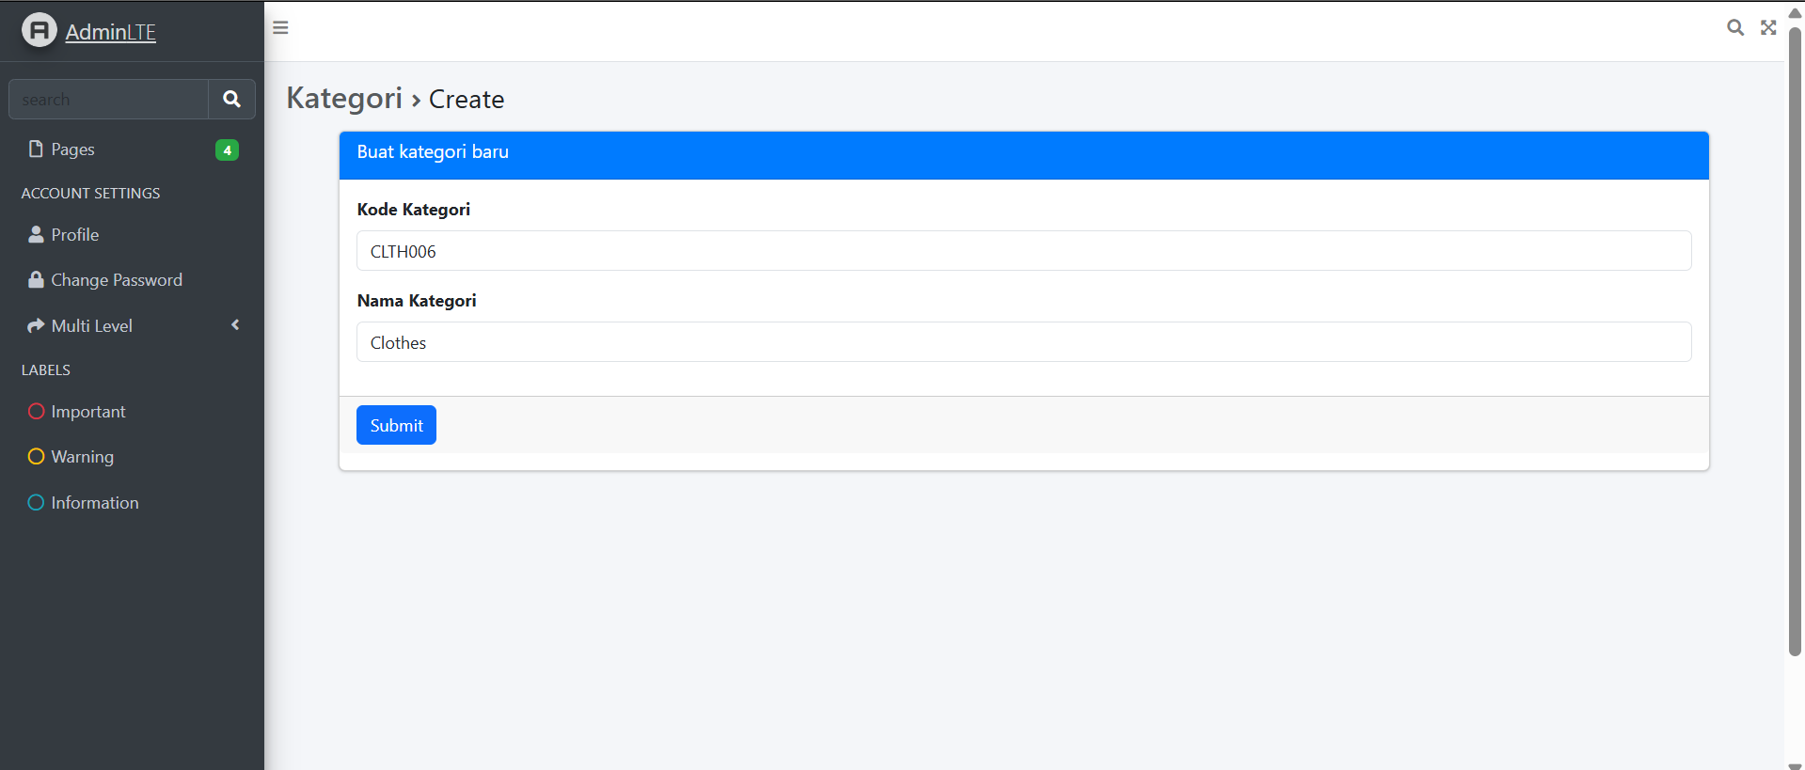

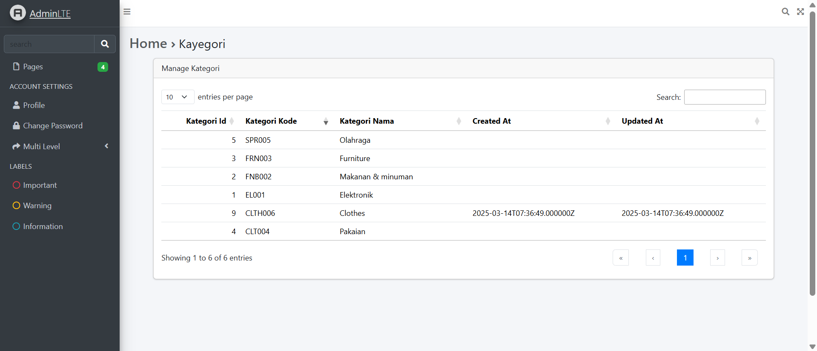

**TUGAS PRAKTIKUM**

1. Tambahkan button Add di halam manage kategori, yang mengarah ke create kategori baru

* resource/views/kategori/index.blade.php

@extends('layouts.app')

{{-- Customize layout sections --}}

@section('subtitle', 'Kategori')

@section('content_header_title', 'Home')

@section('content_header_subtitle', 'Kategori')

@section('content')

<div class="container">

<div class="card">

<div class="card-header">Manage Kategori</div>

<div class="card-body">

<a href="{{ route('kategori.create') }}" class="btn btn-primary ">Add</a>

{{ $dataTable->table() }}

</div>

</div>

</div>

</div>

@endsection

@push('scripts')

{{ $dataTable->scripts() }}

@endpush

web.php

<?php

use App\Http\Controllers\LevelController;

use App\Http\Controllers\UserController;

use App\Http\Controllers\KategoriController;

use Illuminate\Support\Facades\Route;

/*

|--------------------------------------------------------------------------

| Web Routes

|--------------------------------------------------------------------------

|

| Here is where you can register web routes for your application. These

| routes are loaded by the RouteServiceProvider and all of them will

| be assigned to the "web" middleware group. Make something great!

|

*/

Route::get('/', function () {

return view('welcome');

});

Route::get('/level', [LevelController::class, 'index']);

Route::get('/kategori', [KategoriController::class, 'index']);

Route::get('/user', [UserController::class, 'index']);

Route::post('/user/tambah_simpan', [UserController::class, 'tambah_simpan']);

Route::get('/user/ubah/{id}', [UserController::class, 'ubah']);

Route::get('/kategori/create', [KategoriController::class, 'create']);

Route::post('/kategori', [KategoriController::class, 'store']);

Route::get('kategori/create', [KategoriController::class, 'create'])->name('kategori.create');

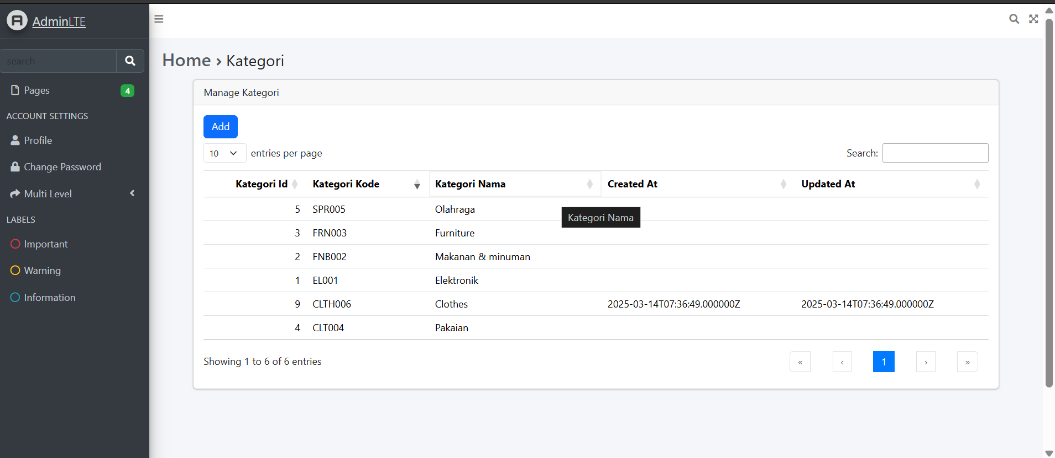

1. Tambahkan menu untuk halaman manage kategori, di daftar menu navbar

* config/adminlte.php

[

'text' => 'Manage Kategori',

'url' => 'kategori',

'icon' => 'fas fa-fw fa-list',

],

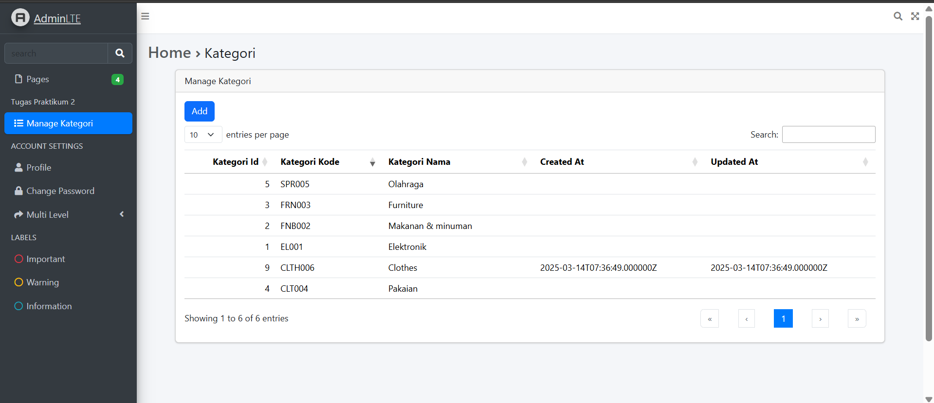

1. Tambahkan action edit di datatables dan buat halaman edit serta controllernya

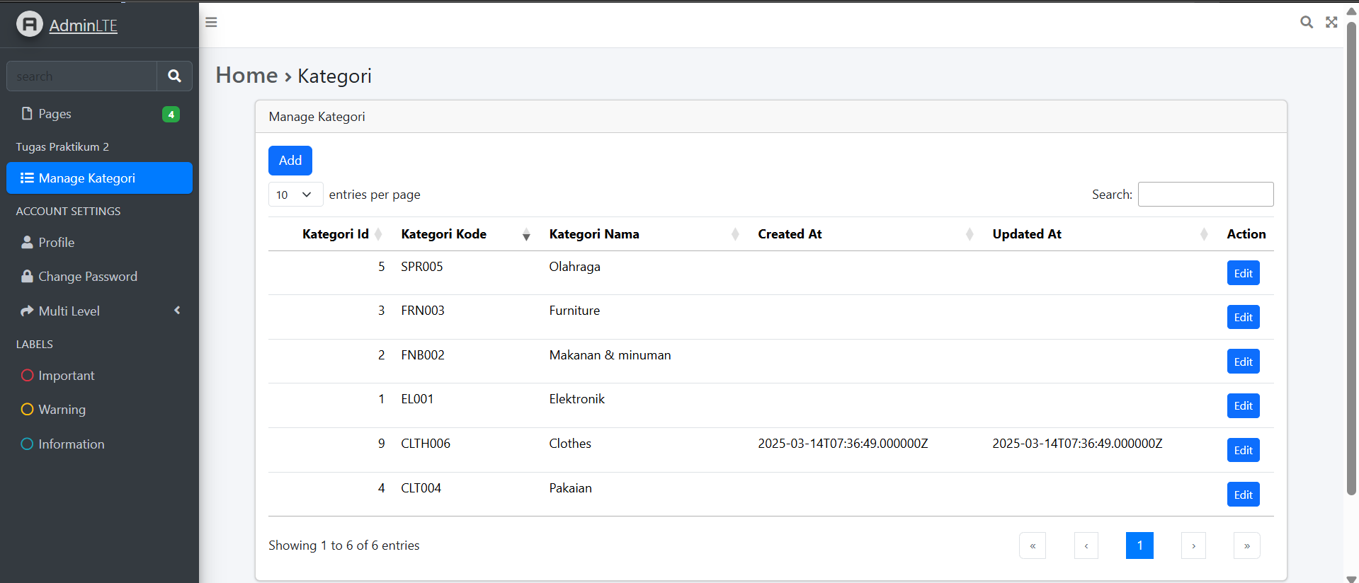

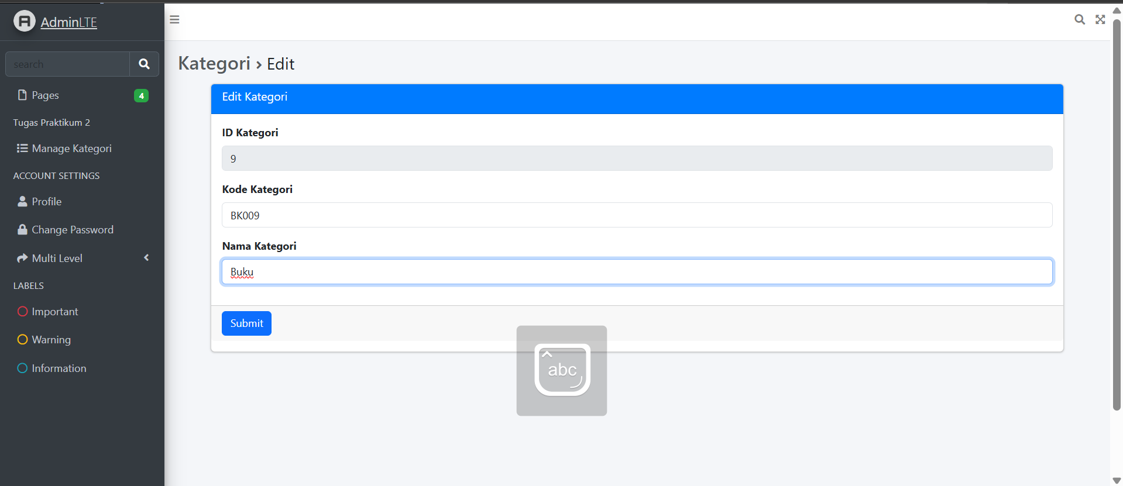

1. Tambahkan action delete di datatables serta controllernya

